|  |  |
| --- | --- |
| Ex.No:7 | **WEB DESIGN FOR SOFTWARE PRODUCT COMPANY** |
| Date: |

AIM:

To design a static website for software product company company.

ALGORITHM:

Step 1: Requirement collection.

Step 2: Creating the layout using HTML and CSS.

Step 3: Updating the sample content.

Step 4: Choose the appropriate style and color scheme.

Step 5: Validate the layout in various browsers.

Step 6: Validate the HTML and CSS code.

Step 7: Publish the website in the given URL.

PROGRAM:

HTML:

home.html

<html>

 <head>

 <meta name="viewport" content="width=device-width, initial-scale=1.0">

 <title> Software Development Company </title>

 <style type="text/css">

 * {

 margin: 0;

 padding: 0;

 font-family: Arial, Helvetica, sans-serif;

 }

 .banner {

 width: 100%;

 height: 100vh;

backgroundimage:lineargradient(rgba(253,114,0,0.848),rgba(0,0,0,0.75)),url(background.jpg)

;

 background-size: cover;

 background-position: center;

 }

 .navbar {

 width: 85%;

 margin: auto;

 padding: 35px 0;

 display: flex;

 align-items: center;

 justify-content: space-between;

 }

 .logo {

 color: #5500ff;

 font-size: 40px;

 font-weight: 700;

 letter-spacing: 3px;

 }

 span {

 color: rgb(54, 249, 11);

 }

 form {

 width: 300px;

 height: 40px;

 display: flex;

 background: rgba(255, 255, 255, 0.2);

 padding: 1px 1px;

 font-size: 15px;

 border-radius: 10px;

 backdrop-filter: blur(4px) saturate(180%);

 }

 form input {

 background: transparent;

 flex: 1;

 border: 0;

 outline: none;

 padding: 12px 20px;

 font-size: 15px;

 color: white;

 }

 ::placeholder {

 color: white;

 }

 form button {

 border: 0;

 outline: none;

 padding: 5px 20px;

 color: white;

 border-radius: 10px;

 background: #1004f5;

 cursor: pointer;

 }

 .navbar li {

 list-style: none;

 display: inline-block;

 margin: 0 20px;

 position: relative;

 }

 .navbar li a {

 text-decoration: none;

 color: white;

 text-transform: uppercase;

 }

 .navbar li:hover {

 border: 1px;

 padding: 10px;

 color: white;

 background-color: #0814fc;

 transition: 0.5s;

 cursor: pointer;

 border-radius: 30px;

 }

 .content {

 position: absolute;

 top: 50%;

 left: 50%;

 transform: translate(-50%,-50%);

 text-align: center;

 }

 .text h2 {

 color: white;

 font-weight: 800;

 font-size: 50px;

 letter-spacing: 3px;

 }

 .text p {

 color: white;

 text-transform: capitalize;

 font-size: 15px;

 margin-bottom: 30px;

 word-spacing: 2px;

 letter-spacing: 1px;

 }

 .login {

 margin: 0px 10px;

 border: 2px solid #0828f8;

 padding: 13px 35px;

 letter-spacing: 1px;

 color: white;

 border-radius: 30px;

 background-color: #0e12f5;

 text-decoration: none;

 }

 .login:hover {

 border: 2px solid #0e12f5;

 color: #6fa1f8;

 background-color: white;

 transition: 0.5s;

 cursor: pointer;

 }

 .signup {

 margin: 0px 10px;

 border: 2px solid #0e12f5;

 padding: 13px 35px;

 letter-spacing: 1px;

 color: white;

 border-radius: 30px;

 background-color: #0e12f5;

 text-decoration: none;

 }

 .signup:hover {

 border: 2px solid #0e12f5;

 color: #6fa1f8;

 background-color: white;

 transition: 0.5s;

 cursor: pointer;

 }

 footer {

 background-color: #0e25f5;

 margin-top: auto;

 }

 </style>

 </head>

<body>

 <div class="banner">

 <br>

 <div class="navbar">

 <h1 class="logo">C<span>ode</span>A<span>cadmey</span></h1>

 <ul>

 <li><a href="http://127.0.0.1:8000/static/home.html"> Home </a></li>

 <li><a href="http://127.0.0.1:8000/static/product.html"> Products </a></li>

 <li><a href="http://127.0.0.1:8000/static/people.html"> People </a></li>

 <li><a href="http://127.0.0.1:8000/static/contact.html"> Contact </a></li>

 </ul>

 <form action="" method="get">

 <input type="text" placeholder="Enter to Search">

 <button type="submit"> Search </button>

 </form>

 </div>

 <div class="content">

 <div class="text">

 <h2> Web Development </h2>

 <br>

 <p> If you're just getting started learning to code, Codecademy is a great way to

get a sense for what coding is and how it works! </p>

 <br>

 <div>

 <a href="#" class="login"> Log In </a>

 <a href="#" class="signup"> Sign Up </a>

 </div>

 </div>

 </div>

 </div>

 <footer>

 <center> Designed and Developed by Nithi </center>

 </footer>

</body>

</html>

products.html

<html>

 <head>

 <meta name="viewport" content="width=device-width, initial-scale=1.0">

 <title> Product Page </title>

 <style type="text/css">

 * {

 margin: 0;

 padding: 0;

 font-family: Arial, Helvetica, sans-serif;

 }

 .banner {

 width: 100%;

 height: 100vh;

 background-image: linear-gradient(rgba(254, 138, 14,

0.859),rgba(0,0,0,0.75)),url(background.jpg);

 background-size: cover;

 background-position: center;

 }

 .navbar {

 width: 85%;

 margin: auto;

 padding: 35px 0;

 display: flex;

 align-items: center;

 justify-content: space-between;

 }

 .bg-product {

 border: 1px;

 padding: 10px;

 color: white;

 background-color: #0004fd;

 border-radius: 30px;

 }

 .logo {

 color: #0213fa;

 font-size: 40px;

 font-weight: 700;

 letter-spacing: 3px;

 }

 span {

 color: rgb(29, 250, 8);

 }

 form {

 width: 300px;

 height: 40px;

 display: flex;

 background: rgba(255, 255, 255, 0.2);

 padding: 1px 1px;

 font-size: 15px;

 border-radius: 10px;

 backdrop-filter: blur(4px) saturate(180%);

 }

 form input {

 background: transparent;

 flex: 1;

 border: 0;

 outline: none;

 padding: 12px 20px;

 font-size: 15px;

 color: white;

 }

 ::placeholder {

 color: white;

 }

 form button {

 border: 0;

 outline: none;

 padding: 5px 20px;

 color: white;

 border-radius: 10px;

 background: #3606e4;

 cursor: pointer;

 }

 .navbar li {

 list-style: none;

 display: inline-block;

 margin: 0 20px;

 position: relative;

 }

 .navbar li a {

 text-decoration: none;

 color: white;

 text-transform: uppercase;

 }

 .navbar li:hover {

 border: 1px;

 padding: 10px;

 color: white;

 background-color: #2f0bfa;

 transition: 0.5s;

 cursor: pointer;

 border-radius: 30px;

 }

 .container {

 background: transparent;

 padding: 10px 5%;

 padding-bottom: 100px;

 }

 .container .box-container {

 display: grid;

 grid-template-columns: repeat(auto-fit, minmax(170px, 1fr));

 gap: 20px;

 }

 .container .box-container .box {

 color: white;

 box-shadow: 0 5px 10px rgba(0,0,0,.2);

 border-radius: 20px;

 background: transparent;

 border: 1px solid white;

 padding: 30px 20px;

 }

 .container .box-container .box img {

 height: 70px;

 border-radius: 20px;

 }

 .container .box-container .box h3 {

 color: #300eef;

 font-size: large;

 padding: 10px 0;

 }

 .container .box-container .box p {

 color: white;

 font-size: small;

 line-height: 1.5;

 }

 footer {

 background-color: #2e0cf3;

 margin-top: auto;

 }

 </style>

 </head>

<body>

 <div class="banner">

 <br>

 <div class="navbar">

 <h1 class="logo">C<span>ode</span>A<span>cademy</span></h1>

 <ul>

 <li><a href="http://127.0.0.1:8000/static/home.html"> Home </a></li>

 <li><a href="http://127.0.0.1:8000/static/product.html" class="bg-product">

Products </a></li>

 <li><a href="http://127.0.0.1:8000/static/people.html"> People </a></li>

 <li><a href="http://127.0.0.1:8000/static/contact.html"> Contact </a></li>

 </ul>

 <form action="" method="get">

 <input type="text" placeholder="Enter to Search">

 <button type="submit"> Search </button>

 </form>

 </div>

 <div class="container">

 <div class="box-container">

 <div class="box">

 <img src="google.png" alt="">

 <h3> Google </h3>

 <p> Top tech company, famous for search and online services. </p>

 </div>

 <div class="box">

 <img src="apple.png" alt="">

 <h3> Apple </h3>

 <p> Tech powerhouse, famed for iphones,macs, and innovation. </p>

 </div>

 <div class="box">

 <img src="u.png" alt="">

 <h3> Uber </h3>

 <p> Ride and food app, global transportation game-changer. </p>

 </div>

 <div class="box">

 <img src="meta.png" alt="">

 <h3> Meta </h3>

 <p> Social media powerhouse, home to facebook, instagram, and more. </p>

 </div>

 <div class="box">

 <img src="idm.png" alt="">

 <h3> IDM </h3>

 <p> Internet Download manager, widely used for efficient file downloads. </p>

 </div>

 <div class="box">

 <img src="windows.png" alt="">

 <h3> Microsoft </h3>

 <p> Tech giant, known for windows office, and cloud services. </p>

 </div>

 <div class="box">

 <img src="Screenshot from 2023-12-28 23-22-30.png" alt="">

 <h3> Reddit </h3>

 <p> Diverse social platform for content sharing and discussion. </p>

 </div>

 <div class="box">

 <img src="spotify.png" alt="">

 <h3> Spotify </h3>

 <p> Top music streaming service with songs,podcasts, and playlists. </p>

 </div>

 <div class="box">

 <img src="youtube.png" alt="">

 <h3> Youtube </h3>

 <p> Global video-sharing giant for diverse content and engagement. </p>

 </div>

 <div class="box">

 <img src="atoz.png" alt="">

 <h3> Amazon </h3>

 <p> E-commerce giant with prime,streaming, and cloud services. </p>

 </div>

 <div class="box">

 <img src="insta.png" alt="">

 <h3> Instagram </h3>

 <p> Visual-centric social platform for photo and video sharing. </p>

 </div>

 <div class="box">

 <img src="meta1.png" alt="">

 <h3> Meta </h3>

 <p> Social media powerhouse, home to facebook, instagram, and more. </p>

 </div>

 </div>

 </div>

 </div>

 <footer>

 <center> Designed and Developed by Nithi</center>

 </footer>

</body>

</html>

contant.html

<html>

 <head>

 <meta name="viewport" content="width=device-width, initial-scale=1.0">

 <title> Contact Us Page </title>

 <style type="text/css">

 * {

 margin: 0;

 padding: 0;

 font-family: Arial, Helvetica, sans-serif;

 }

 .banner {

 width: 100%;

 height: 100vh;

 background-image: linear-gradient(rgba(255, 135, 6,

0.886),rgba(0,0,0,0.75)),url(background.jpg);

 background-size: cover;

 background-position: center;

 }

 .navbar {

 width: 85%;

 margin: auto;

 padding: 35px 0;

 display: flex;

 align-items: center;

 justify-content: space-between;

 }

 .bg-contact {

 border: 1px;

 padding: 10px;

 color: white;

 background-color: #0824fd;

 border-radius: 30px;

 }

 .logo {

 color: #091dfa;

 font-size: 40px;

 font-weight: 700;

 letter-spacing: 3px;

 }

 span {

 color: rgb(81, 246, 10);

 }

 .navbar form {

 width: 300px;

 height: 40px;

 display: flex;

 background: rgba(255, 255, 255, 0.2);

 padding: 1px 1px;

 font-size: 15px;

 border-radius: 10px;

 backdrop-filter: blur(4px) saturate(180%);

 }

 .navbar form input {

 background: transparent;

 flex: 1;

 border: 0;

 outline: none;

 padding: 12px 20px;

 font-size: 15px;

 color: white;

 }

 ::placeholder {

 color: white;

 }

 .navbar form button {

 border: 0;

 outline: none;

 padding: 5px 20px;

 color: white;

 border-radius: 10px;

 background: #0521f8;

 cursor: pointer;

 }

 .navbar li {

 list-style: none;

 display: inline-block;

 margin: 0 20px;

 position: relative;

 }

 .navbar li a {

 text-decoration: none;

 color: white;

 text-transform: uppercase;

 }

 .navbar li:hover {

 border: 1px;

 padding: 10px;

 color: white;

 background-color: #0630fe;

 transition: 0.5s;

 cursor: pointer;

 border-radius: 30px;

 }

 .box {

 display: flex;

 column-gap: 40px;

 background: transparent;

 position: relative;

 top: 50px;

 }

 .box-1 {

 height: 400px;

 width: 400px;

 border: 3px solid white;

 border-radius: 20px;

 background: transparent;

 position: relative;

 left: 250px;

 }

 .box-2 {

 height: 400px;

 width: 400px;

 border: 3px solid #0909fb;

 border-radius: 20px;

 background: transparent;

 position: relative;

 left: 300px;

 }

 .box-1 form {

 display: flex;

 color: white;

 background: transparent;

 padding: 10px;

 font-size: 15px;

 position: relative;

 top: 15px;

 }

 .box-1 form input {

 background: transparent;

 display: flex;

 border: 1px solid white;

 border-radius: 10px;

 padding: 15px 30px;

 font-size: 15px;

 color: white;

 position: relative;

 top: 30px;

 }

 .box-1 form textarea {

 background: transparent;

 color: white;

 padding: 15px 10px;

 position: relative;

 top: 30px;

 left: 30px;

 border: 1px solid white;

 border-radius: 10px;

 }

 .box-1 form button {

 border: 0;

 outline: none;

 padding: 10px 20px;

 color: white;

 border-radius: 30px;

 background: #0804ed;

 cursor: pointer;

 position: relative;

 top: 50px;

 }

 .box-2 h2 {

 color: white;

 position: relative;

 top: 25px;

 left: 50px;

 font-size: 30px;

 }

 .box-2 p {

 color: white;

 position: relative;

 top: 50px;

 padding: 10px 80px;

 }

 .box-2 span {

 color: #0d09f8;

 font-size: 20px;

 }

 footer {

 background-color: #250af6;

 margin-top: auto;

 }

 </style>

 </head>

<body>

 <div class="banner">

 <br>

 <div class="navbar">

 <h1 class="logo">C<span>ode</span>A<span>cademy</span></h1>

 <ul>

 <li><a href="http://127.0.0.1:8000/static/home.html"> Home </a></li>

 <li><a href="http://127.0.0.1:8000/static/product.html"> Products </a></li>

 <li><a href="http://127.0.0.1:8000/static/people.html"> People </a></li>

 <li><a href="http://127.0.0.1:8000/static/contact.html" class="bg-contact">

Contact </a></li>

 </ul>

 <form action="" method="get">

 <input type="text" placeholder="Enter to Search">

 <button type="submit"> Search </button>

 </form>

 </div>

 <div class="box">

 <div class="box-1">

 <form>

 <center>

 <h1> Contact Us </h1>

 <input type="text" placeholder="Your Name">

 <br>

 <input type="email" placeholder="Your Email">

 <br>

 <textarea rows="4" cols="40" placeholder="Your Message"> </textarea>

 <br>

 <button type="submit"> Submit </button>

 </center>

 </form>

 </div>

 <div class="box-2">

 <h2> Contact Information </h2>

 <p> <span>Address</span> : 4/108 Annanagar ,natampalli(post),thirupathur</p>

 <p> <span>Email</span> : nithi156@gmail.com </p>

 <p> <span>Phone</span> : 8597462315 </p>

 </div>

 </div>

 </div>

 <footer>

 <center> Designed and Developed by Nithi </center>

 </footer>

</body>

</html>

people.html

<html>

 <head>

 <meta name="viewport" content="width=device-width, initial-scale=1.0">

 <title> people page </title>

 <style type="text/css">

 * {

 margin: 0;

 padding: 0;

 font-family: Arial, Helvetica, sans-serif;

 }

 .banner {

 width: 100%;

 height: 100vh;

 background-image: linear-gradient(rgba(255, 132, 16,

0.837),rgba(0,0,0,0.75)),url(background.jpg);

 background-size: cover;

 background-position: center;

 }

 .navbar {

 width: 85%;

 margin: auto;

 padding: 35px 0;

 display: flex;

 align-items: center;

 justify-content: space-between;

 }

 .bg-people {

 border: 1px;

 padding: 10px;

 color: white;

 background-color: #1c05f3;

 border-radius: 30px;

 }

 .logo {

 color: #0b13f6;

 font-size: 40px;

 font-weight: 700;

 letter-spacing: 3px;

 }

 span {

 color: rgb(71, 250, 5);

 }

 form {

 width: 300px;

 height: 40px;

 display: flex;

 background: rgba(255, 255, 255, 0.2);

 padding: 1px 1px;

 font-size: 15px;

 border-radius: 10px;

 backdrop-filter: blur(4px) saturate(180%);

 }

 form input {

 background: transparent;

 flex: 1;

 border: 0;

 outline: none;

 padding: 12px 20px;

 font-size: 15px;

 color: white;

 }

 ::placeholder {

 color: white;

 }

 form button {

 border: 0;

 outline: none;

 padding: 5px 20px;

 color: white;

 border-radius: 10px;

 background: #060af9;

 cursor: pointer;

 }

 .navbar li {

 list-style: none;

 display: inline-block;

 margin: 0 20px;

 position: relative;

 }

 .navbar li a {

 text-decoration: none;

 color: white;

 text-transform: uppercase;

 }

 .navbar li:hover {

 border: 1px;

 padding: 10px;

 color: white;

 background-color: #050dfe;

 transition: 0.5s;

 cursor: pointer;

 border-radius: 30px;

 }

 .image {

 position: relative;

 border: 0;

 top: 70px;

 background: transparent;

 }

 .image table {

 border: 0;

 color: white;

 position: relative;

 left: 150px;

 }

 .image table img {

 height: 140px;

 width: 140px;

 border: 2px solid white;

 padding: 5px;

 border-radius: 50%;

 }

 .image table td {

 color: #0813f4;

 }

 footer {

 background-color: #080cf7;

 margin-top: auto;

 }

 </style>

 </head>

<body>

 <div class="banner">

 <br>

 <div class="navbar">

 <h1 class="logo">C<span>ode</span>A<span>cademy</span></h1>

 <ul>

 <li><a href="http://127.0.0.1:8000/static/home.html"> Home </a></li>

 <li><a href="http://127.0.0.1:8000/static/product.html"> Products </a></li>

 <li><a href="http://127.0.0.1:8000/static/people.html" class="bg-people"> People

</a></li>

 <li><a href="http://127.0.0.1:8000/static/contact.html"> Contact </a></li>

 </ul>

 <form action="" method="get">

 <input type="text" placeholder="Enter to Search">

 <button type="submit"> Search </button>

 </form>

 </div>

 <div class="image">

 <table cellspacing="20">

 <tr align="center">

 <td> <img src="nithi.jpeg"> </td>

 <td> <img src="M S D.jpeg"> </td>

 <td> <img src="virat.jpeg"> </td>

 <td> <img src="Ravindra Jadeja.jpeg"> </td>

 <td> <img src="pa.jpeg"> </td>

 <td> <img src="KL Rahul.jpeg"> </td>

 </tr>

 <tr align="center">

 <th> Nithi s</th>

 <th> M S Dhoni </th>

 <th> Virat Kohil</th>

 <th> Ravindra Jadeja </th>

 <th> Hardik Pandya </th>

 <th> KL Rahul </th>

 </tr>

 <tr align="center">

 <td> CEO </td>

 <td> CEO, Co-Founder </td>

 <td> CTO, Co-Founder </td>

 <td> Director </td>

 <td> Asst. Director </td>

 <td> Dy. Director </td>

 </tr>

 </table>

 </div>

 </div>

 <footer>

 <center> Designed and Developed by Nithi </center>

 </footer>

</body>

</html>

OUTPUT:

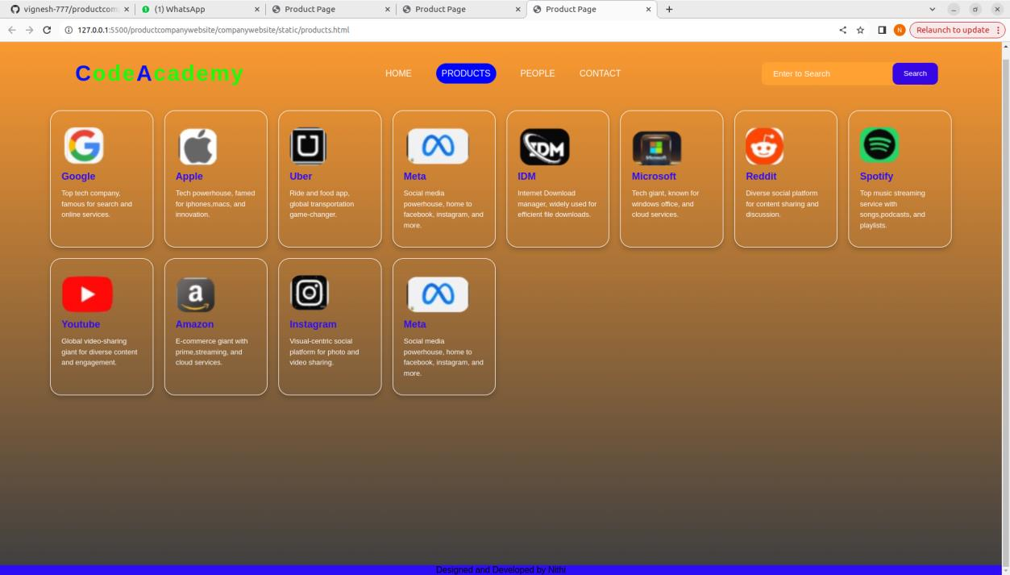

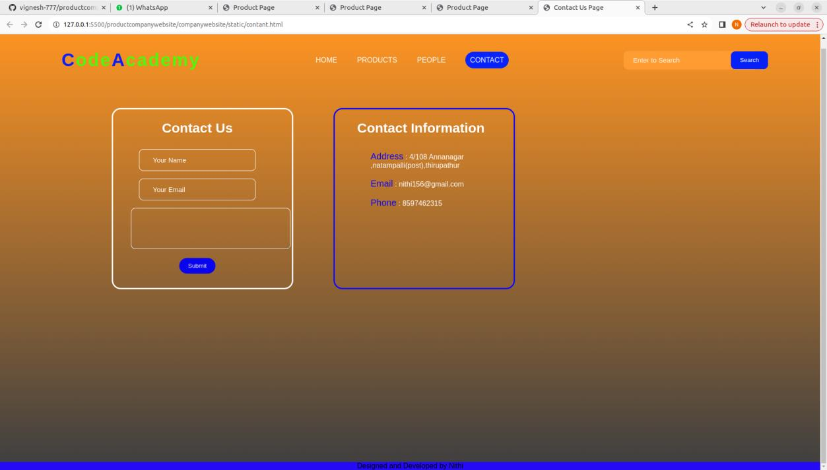

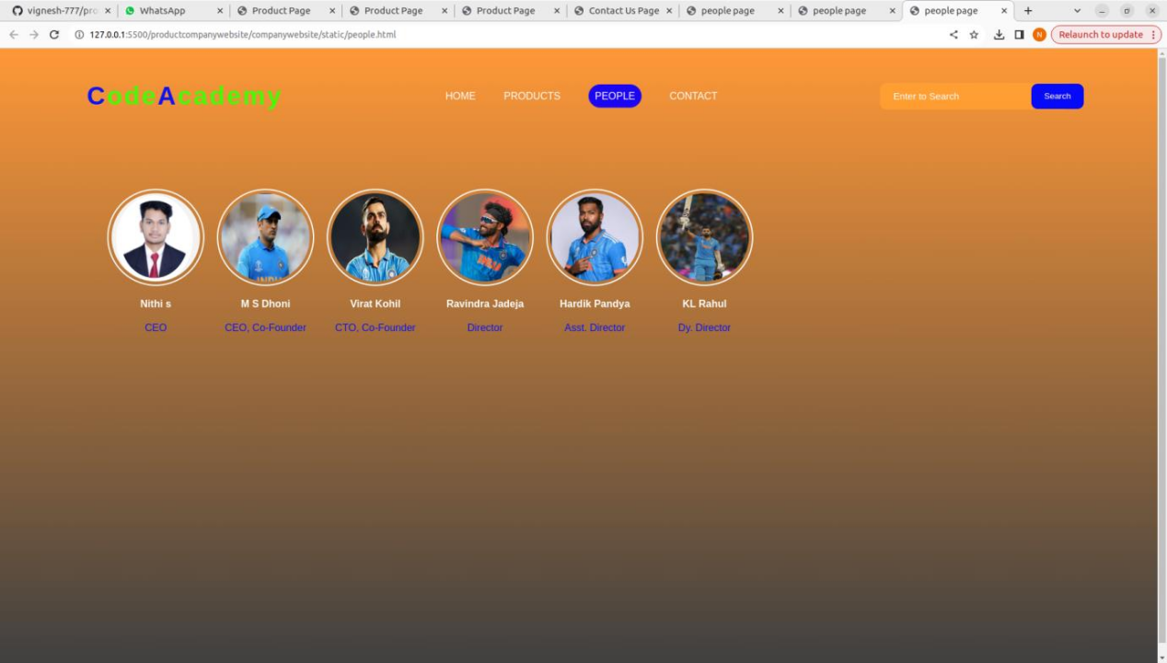

RESULT:

Thus a website is designed for the software product company and the HTML,CSS

code are validated.